**Bumblebee News**

**__________________________________________________________________________________________________________________________________________________________________________________________**

**Wheeless Road Elementary School Title 1 2530 Wheeless Rd., Augusta, GA**

**706) 796-4985 November 30, 2023 4th Edition**

**________________________________________________________________________________________________________________________________________________________________________________________________________________________________**

**Principal’s Corner**

Dear Parents,

I would like to personally thank each and every one of you for your support in contributing to a successful first semester from our Fall Parent Conferences to our Family Thanksgiving dinner to the academic progress each student continues to make daily in the classroom. Thank you for playing an active role in your child's education and supporting our school and teachers. At Wheeless Road Elementary, you will see us “Buzzing to Excellence." Now is the time for you and your loved ones to have a Restful, Outstanding, Awesome, and Radiant Christmas Break! Wishing all the faculty, staff, parents and students of Wheeless Road Elementary a very happy holiday! May this holiday season bring along many more smiles and success stories for you to enjoy. As we approach this holiday season, I extend warm wishes to you and your family. May this holiday be full of good and happy times for you and your family. If you have questions, contact me at Wheeless Road Elementary School at (706) 796-4985.

Sincerely,

Carl Robinson III, Ed.S.

Principal

Wheeless Road Elementary School

(706) 796-4985 (Work)

**“Buzzing to Excellence”**



**HAVE A WONDERFUL HOLIDAY SEASON!!**

**From the Wheeless Road Elementary**

**Faculty and Staff**

***Upcoming Events***

* ***12 Days of Christmas***

*Monday, December 4 – Tuesday, December 19*

* ***WRES Spelling Bee***

*Friday, December 8 (8:00 am)*

* ***Winter Music Program***

*Friday, December 15*

*Pre-K, Kindergarten, & 1st grade: 9:00 am*

*2nd, 3rd, 4th, & 5th grades: 12:30 pm*

* ***Early Release/End of 1st Semester***

*Tuesday, December 19 (12:00)*

* ***Christmas/Winter Break***

*Wednesday, December 20 – January 1*

* ***Student Holiday/ Professional Learning Day***

*Tuesday, January 2 – Wednesday, January 3*

* ***Beginning of 2nd Semester***

*Thursday, January 4*

We have “12 Days of Christmas” planned for December 4-19. Please see schedule below: **As we begin this holiday season, please have your child participate with the teachers and staff in “The 12 Days of Christmas”.**

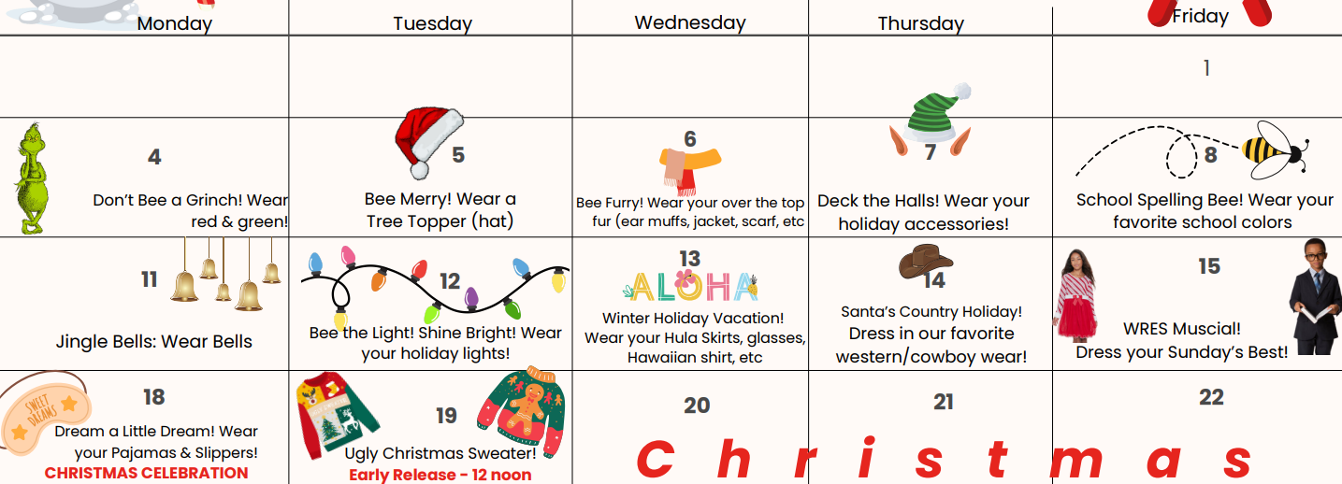



Holiday Celebration

**Christmas Pictures**

**Christmas pictures will be offered for students for $5.00 from December 4 – 11. More information will be coming home soon – look for the flyer to sign up.**

**Winter Music Program**

The Winter Music Program will be performed by the Pre-K through 5th grade students; **parents are welcome to attend.**

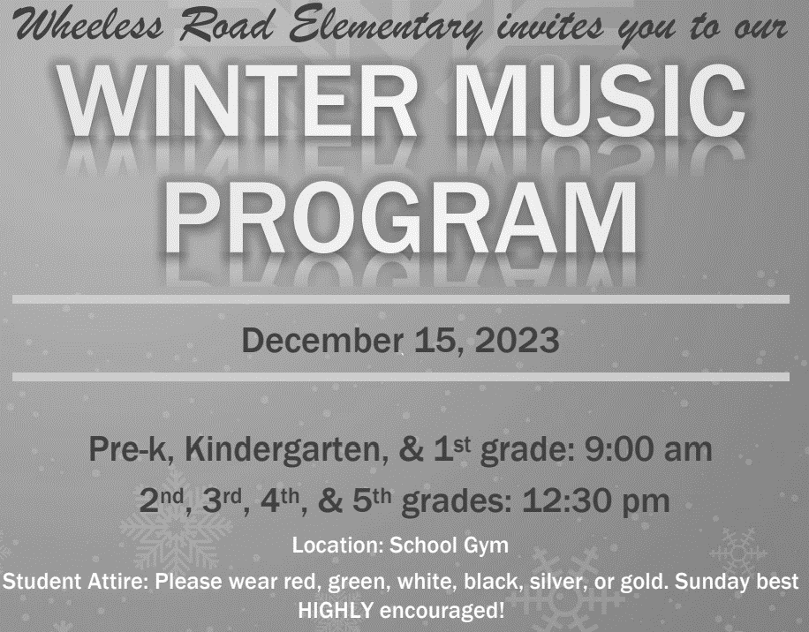

**Holiday Activities for Families**

* Construct a Holiday Photo Booth.
* Make decorations out of cards.
* Bake Unique Holiday Cookies.
* Host A Holiday Game Night or Craft Party.

**Tis the season – to celebrate safely!**

* Keep decorations at least three feet away from heat sources.
* If you have a natural Christmas tree, water it to keep it fresh and safe.
* Inspect your decorations and discard any that are damaged or worn out.
* Always turn off your decorations when you leave your home or when you are sleeping.
* When cooking, pay close attention to what you're doing and your surroundings.
* Keep a fire extinguisher close by. Be sure you have smoke detectors and test them monthly.



**Enjoy the holidays with your family! Happy New Year!**